Rectangular-Base Pyramid
# Source: AI Source: Provided by: [Data Path: Persons Table -> ID Column: 1, Name_En Column: Motasem Essam] -> From: [ChatGPT] on [7/25/2026]
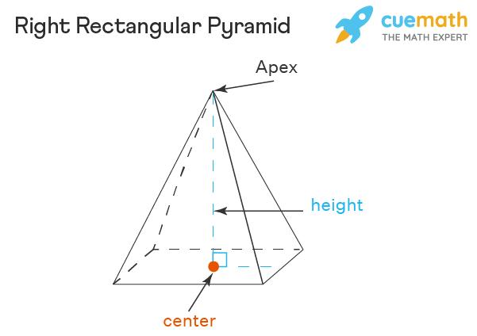
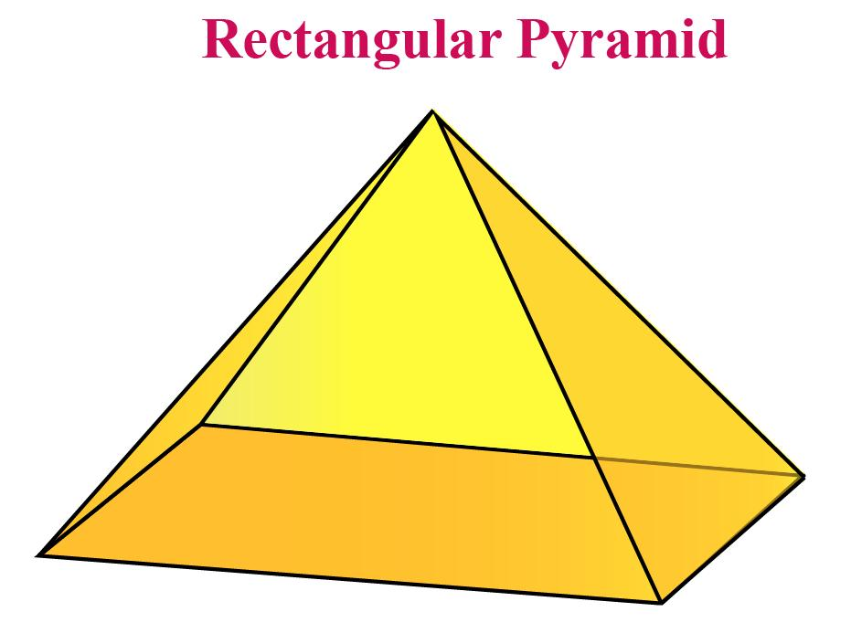
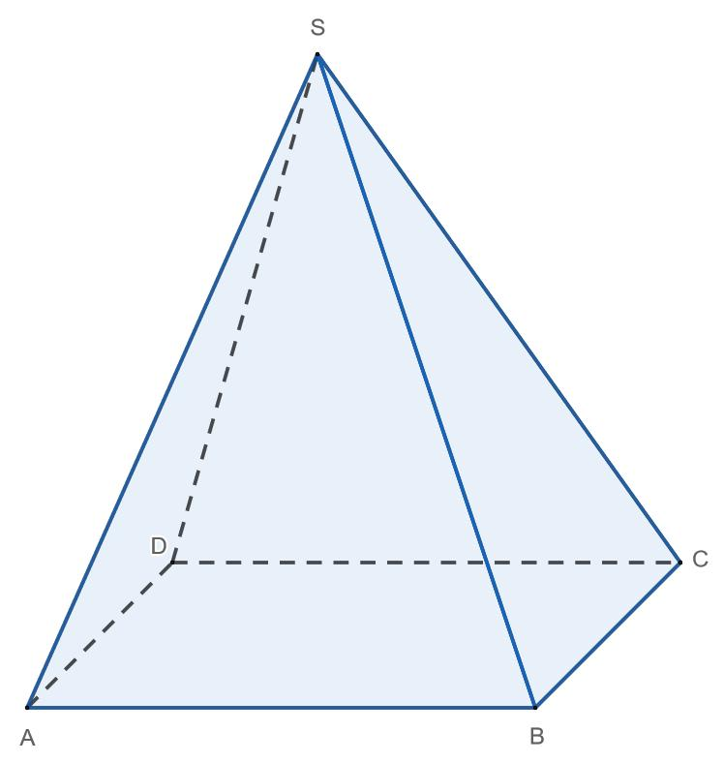

Definition
# Source: AI Source: Provided by: [Data Path: Persons Table -> ID Column: 1, Name_En Column: Motasem Essam] -> From: [ChatGPT] on [7/25/2026]
A rectangular-base pyramid is a three-dimensional polyhedron with a rectangular base and four triangular lateral faces that meet at a single vertex called the apex.
The rectangular base has four sides and four right angles. Opposite sides of the rectangle are equal, but adjacent sides do not have to be equal.
A rectangular-base pyramid has five faces, eight edges, and five vertices. It can be classified as a right rectangular-base pyramid or an oblique rectangular-base pyramid, depending on the position of the apex relative to the designated center of the base.
Important: A square is a special type of rectangle. Therefore, a square-base pyramid is also a rectangular-base pyramid under the inclusive mathematical definition of a rectangle.

Simple Definition
# Source: AI Source: Provided by: [Data Path: Persons Table -> ID Column: 1, Name_En Column: Motasem Essam] -> From: [ChatGPT] on [7/25/2026]
A rectangular-base pyramid is a solid with one rectangular base and four triangular sides that meet at one apex.

Key Characteristics
# Source: AI Source: Provided by: [Data Path: Persons Table -> ID Column: 1, Name_En Column: Motasem Essam] -> From: [ChatGPT] on [7/25/2026]
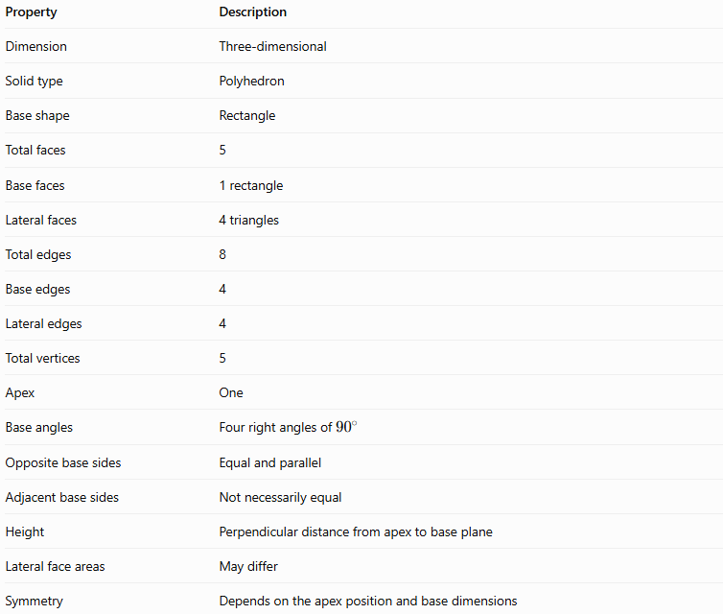
Property | Description
Dimension | Three-dimensional
Solid type | Polyhedron
Base shape | Rectangle
Total faces | 5
Base faces | 1 rectangle
Lateral faces | 4 triangles
Total edges | 8
Base edges | 4
Lateral edges | 4
Total vertices | 5
Apex | One
Base angles | Four right angles of \(90^\circ\)
Opposite base sides | Equal and parallel
Adjacent base sides | Not necessarily equal
Height | Perpendicular distance from apex to base plane
Lateral face areas | May differ
Symmetry | Depends on the apex position and base dimensions

Geometric Representation
# Source: AI Source: Provided by: [Data Path: Persons Table -> ID Column: 1, Name_En Column: Motasem Essam] -> From: [ChatGPT] on [7/25/2026]
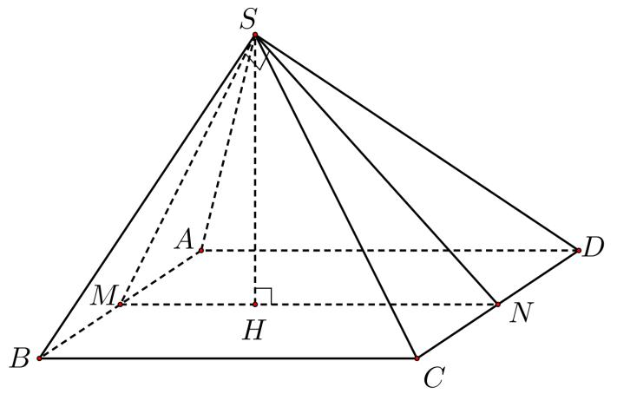
The main components are:
- Rectangular base $ABCD$: The bottom face of the pyramid, with length $a$ and width $b$.
- Apex $S$: The vertex where the four lateral faces meet.
- Base edges $AB$, $BC$, $CD$, and $DA$: The four sides of the rectangular base.
- Lateral edges $SA$, $SB$, $SC$, and $SD$: The edges connecting the apex to the four base vertices.
- Lateral faces $SAB$, $SBC$, $SCD$, and $SDA$: The four triangular side faces.
- Base center $O$: The intersection of the rectangle's diagonals.
- Perpendicular height $h$: The shortest distance from the apex to the plane containing the base.
- Slant heights: The perpendicular altitudes of the lateral triangular faces, measured from the apex to the respective base edges. These may differ.
For a right rectangular-base pyramid, the apex lies directly above the center $O$, so:
$$SO⊥\text{plane}\left(ABCD\right)$$
For an oblique rectangular-base pyramid, the perpendicular projection of the apex onto the base plane does not coincide with the designated center.

Mathematical Representations and Formulas
# Source: AI Source: Provided by: [Data Path: Persons Table -> ID Column: 1, Name_En Column: Motasem Essam] -> From: [ChatGPT] on [7/25/2026]
Let:
- $a$ = length of the rectangular base.
- $b$ = width of the rectangular base.
- $h$ = perpendicular height of the pyramid.
- $B$ = base area.
- $A_{L}$ = lateral surface area.
- $A_{T}$ = total surface area.
- $V$ = volume.

Base area and perimeter
# Source: AI Source: Provided by: [Data Path: Persons Table -> ID Column: 1, Name_En Column: Motasem Essam] -> From: [ChatGPT] on [7/25/2026]
The area of a rectangle is:
$$\boxed{B=ab}$$
Its perimeter is:
$$\boxed{P_{b}=2\left(a+b\right)}$$
Its diagonal length is:
$$\boxed{d=\sqrt{a^{2}+b^{2}}}$$

Number of faces, edges, and vertices
# Source: AI Source: Provided by: [Data Path: Persons Table -> ID Column: 1, Name_En Column: Motasem Essam] -> From: [ChatGPT] on [7/25/2026]
For a pyramid with an $n$-sided base:
$$F=n+1, E=2n, V_{e}=n+1$$
A rectangular base has $n=4$, so:
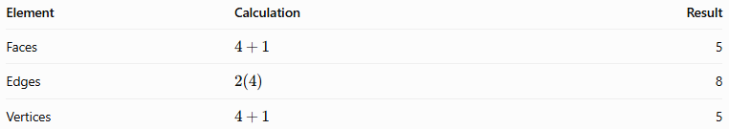
Element | Calculation | Result
Faces | $$4+1$$ | 5
Edges | $$2\left(4\right)$$ | 8
Vertices | $$4+1$$ | 5
Euler's formula for convex polyhedra is:
$$V_{e}-E+F=2$$
Substituting:
$$5-8+5=2$$
Therefore, the rectangular-base pyramid satisfies Euler's formula.

Volume
# Source: AI Source: Provided by: [Data Path: Persons Table -> ID Column: 1, Name_En Column: Motasem Essam] -> From: [ChatGPT] on [7/25/2026]
The volume of any pyramid is one-third of its base area multiplied by its perpendicular height:
$$V=\frac{1}{3}Bh$$
Since the base area is $ab$:
$$\boxed{V=\frac{1}{3}abh}$$
This formula applies to both right and oblique rectangular-base pyramids.

Lateral surface area
# Source: AI Source: Provided by: [Data Path: Persons Table -> ID Column: 1, Name_En Column: Motasem Essam] -> From: [ChatGPT] on [7/25/2026]
For a general rectangular-base pyramid, calculate each triangular face separately:
$$\boxed{A_{L}=A_{1}+A_{2}+A_{3}+A_{4}}$$
For a right rectangular-base pyramid, let:
- $l_{a}$ be the slant height of each triangular face whose base has length $a$.
- $l_{b}$ be the slant height of each triangular face whose base has length $b$.
Opposite faces are congruent in this right-pyramid arrangement. Thus:
$$A_{L}=2\left(\frac{1}{2}al_{a}\right)+2\left(\frac{1}{2}bl_{b}\right)$$
Simplifying:
$$\boxed{A_{L}=al_{a}+bl_{b}}$$
Unlike a right square pyramid, a right rectangular-base pyramid generally has two different slant heights because the rectangle's length and width may differ.

Total surface area
# Source: AI Source: Provided by: [Data Path: Persons Table -> ID Column: 1, Name_En Column: Motasem Essam] -> From: [ChatGPT] on [7/25/2026]
For a right rectangular-base pyramid:
$$A_{T}=B+A_{L}$$
Therefore:
$$\boxed{A_{T}=ab+al_{a}+bl_{b}}$$
For an oblique rectangular-base pyramid, use the general formula:
$$\boxed{A_{T}=ab+A_{1}+A_{2}+A_{3}+A_{4}}$$
The simplified formula for a right pyramid should not be applied to an arbitrary oblique pyramid unless its face geometry supports the same relationships.

Slant heights for a right rectangular-base pyramid
# Source: AI Source: Provided by: [Data Path: Persons Table -> ID Column: 1, Name_En Column: Motasem Essam] -> From: [ChatGPT] on [7/25/2026]
When the apex lies above the center of the rectangle, the distance from the base center to the midpoint of a side of length $a$ is $b/2$. Therefore:
$$\boxed{l_{a}=\sqrt{h^{2}+{\left(\frac{b}{2}\right)}^{2}}}$$
Similarly, for a side of length $b$:
$$\boxed{l_{b}=\sqrt{h^{2}+{\left(\frac{a}{2}\right)}^{2}}}$$
These equations follow from the Pythagorean theorem.

Worked Examples
# Source: AI Source: Provided by: [Data Path: Persons Table -> ID Column: 1, Name_En Column: Motasem Essam] -> From: [ChatGPT] on [7/25/2026]
Example 1: Calculating base area and perimeter
A rectangular-base pyramid has a base length of $10\text{ cm}$ and width of $6\text{ cm}$.
Base area:
$$B=ab=10\left(6\right)$$
$$\boxed{B=60{\text{ cm}}^{2}}$$
Base perimeter:
$$P_{b}=2\left(a+b\right)=2\left(10+6\right)$$
$$\boxed{P_{b}=32\text{ cm}}$$
Example 2: Calculating volume
A rectangular-base pyramid has a base length of $12\text{ cm}$, width of $8\text{ cm}$, and perpendicular height of $9\text{ cm}$.
Using:
$$V=\frac{1}{3}abh$$
Substitute:
$$V=\frac{1}{3}\left(12\right)\left(8\right)\left(9\right)$$
$$V=\frac{864}{3}$$
$$\boxed{V=288{\text{ cm}}^{3}}$$
Answer: The volume is $288{\text{ cm}}^{3}$.
Example 3: Calculating total surface area
A right rectangular-base pyramid has:
- Base length $a=8\text{ cm}$
- Base width $b=6\text{ cm}$
- Perpendicular height $h=4\text{ cm}$
Step 1: Calculate the base area.
$$B=ab=8\left(6\right)=48{\text{ cm}}^{2}$$
Step 2: Calculate the two slant heights.
For the faces with base length $8\text{ cm}$:
$$l_{a}=\sqrt{4^{2}+\left(\frac{6}{2})^{2}\right.}=\sqrt{16+9}=5\text{ cm}$$
For the faces with base length $6\text{ cm}$:
$$l_{b}=\sqrt{4^{2}+\left(\frac{8}{2})^{2}\right.}=\sqrt{16+16}=4\sqrt{2}\text{ cm}$$
Step 3: Calculate the lateral surface area.
$$A_{L}=al_{a}+bl_{b}$$
$$A_{L}=8\left(5\right)+6\left(4\sqrt{2}\right)$$
$$A_{L}=40+24\sqrt{2}$$
Step 4: Calculate the total surface area.
$$A_{T}=48+40+24\sqrt{2}$$
$$\boxed{A_{T}=88+24\sqrt{2}{\text{ cm}}^{2}}$$
Approximately:
$$\boxed{A_{T}≈121.94{\text{ cm}}^{2}}$$

Comparison with Related Concepts
# Source: AI Source: Provided by: [Data Path: Persons Table -> ID Column: 1, Name_En Column: Motasem Essam] -> From: [ChatGPT] on [7/25/2026]
Rectangular-Base Pyramid
Has one rectangular base and four triangular lateral faces. Its length and width may differ.
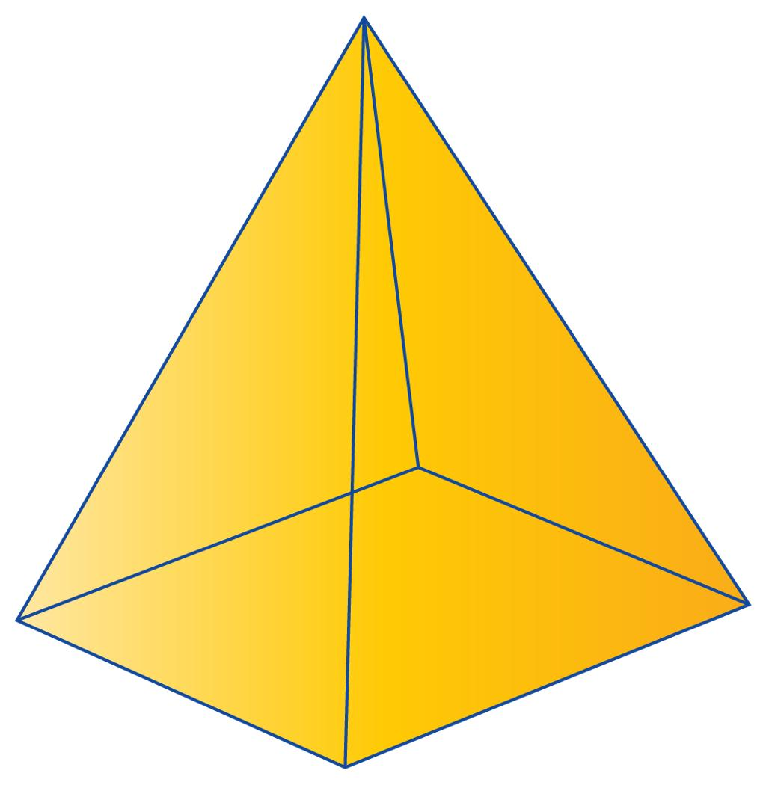
Square-Base Pyramid
Has a square base, which means all four base sides are equal. It is a special case of a rectangular-base pyramid.
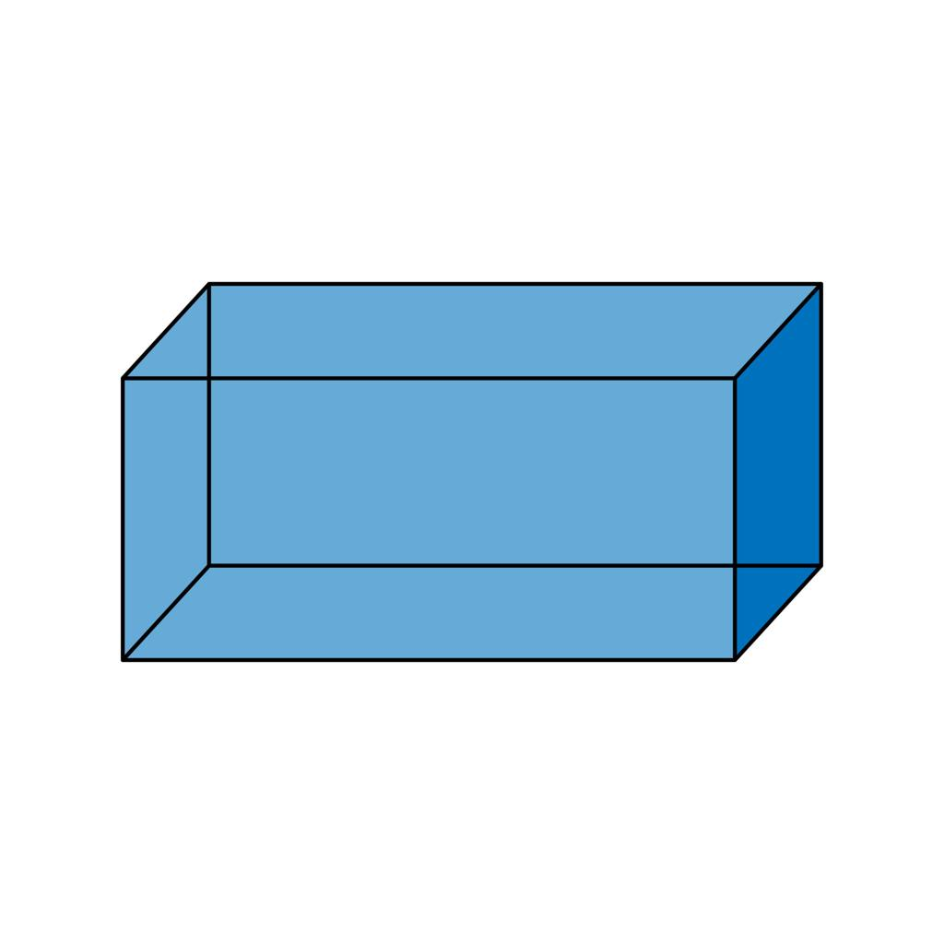
Rectangular Prism
Has two parallel, congruent rectangular bases and four lateral faces that are parallelograms. It has no single apex.
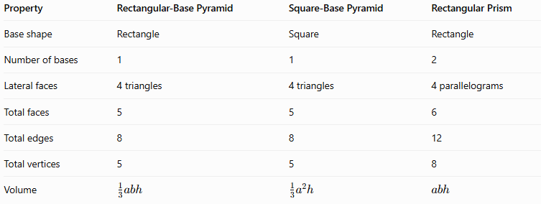
Property | Rectangular-Base Pyramid | Square-Base Pyramid | Rectangular Prism
Base shape | Rectangle | Square | Rectangle
Number of bases | 1 | 1 | 2
Lateral faces | 4 triangles | 4 triangles | 4 parallelograms
Total faces | 5 | 5 | 6
Total edges | 8 | 8 | 12
Total vertices | 5 | 5 | 8
Volume | $$\frac{1}{3}abh$$ | $$\frac{1}{3}a^{2}h$$ | $$abh$$

Constructing Rectangular-Base Pyramid in Solid Geometry

Instruments Used
# Source: AI Source: Provided by: [Data Path: Persons Table -> ID Column: 1, Name_En Column: Motasem Essam] -> From: [ChatGPT] on [7/25/2026]
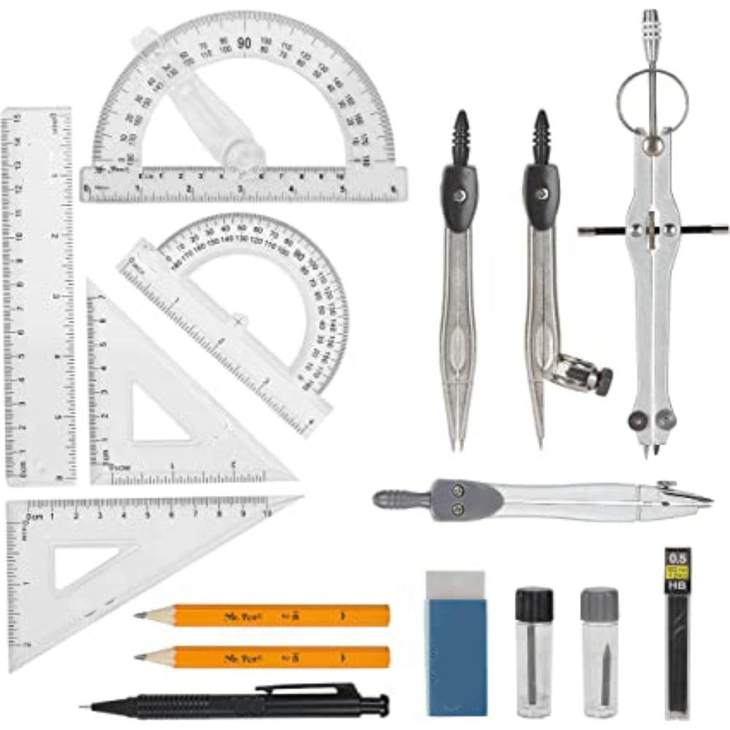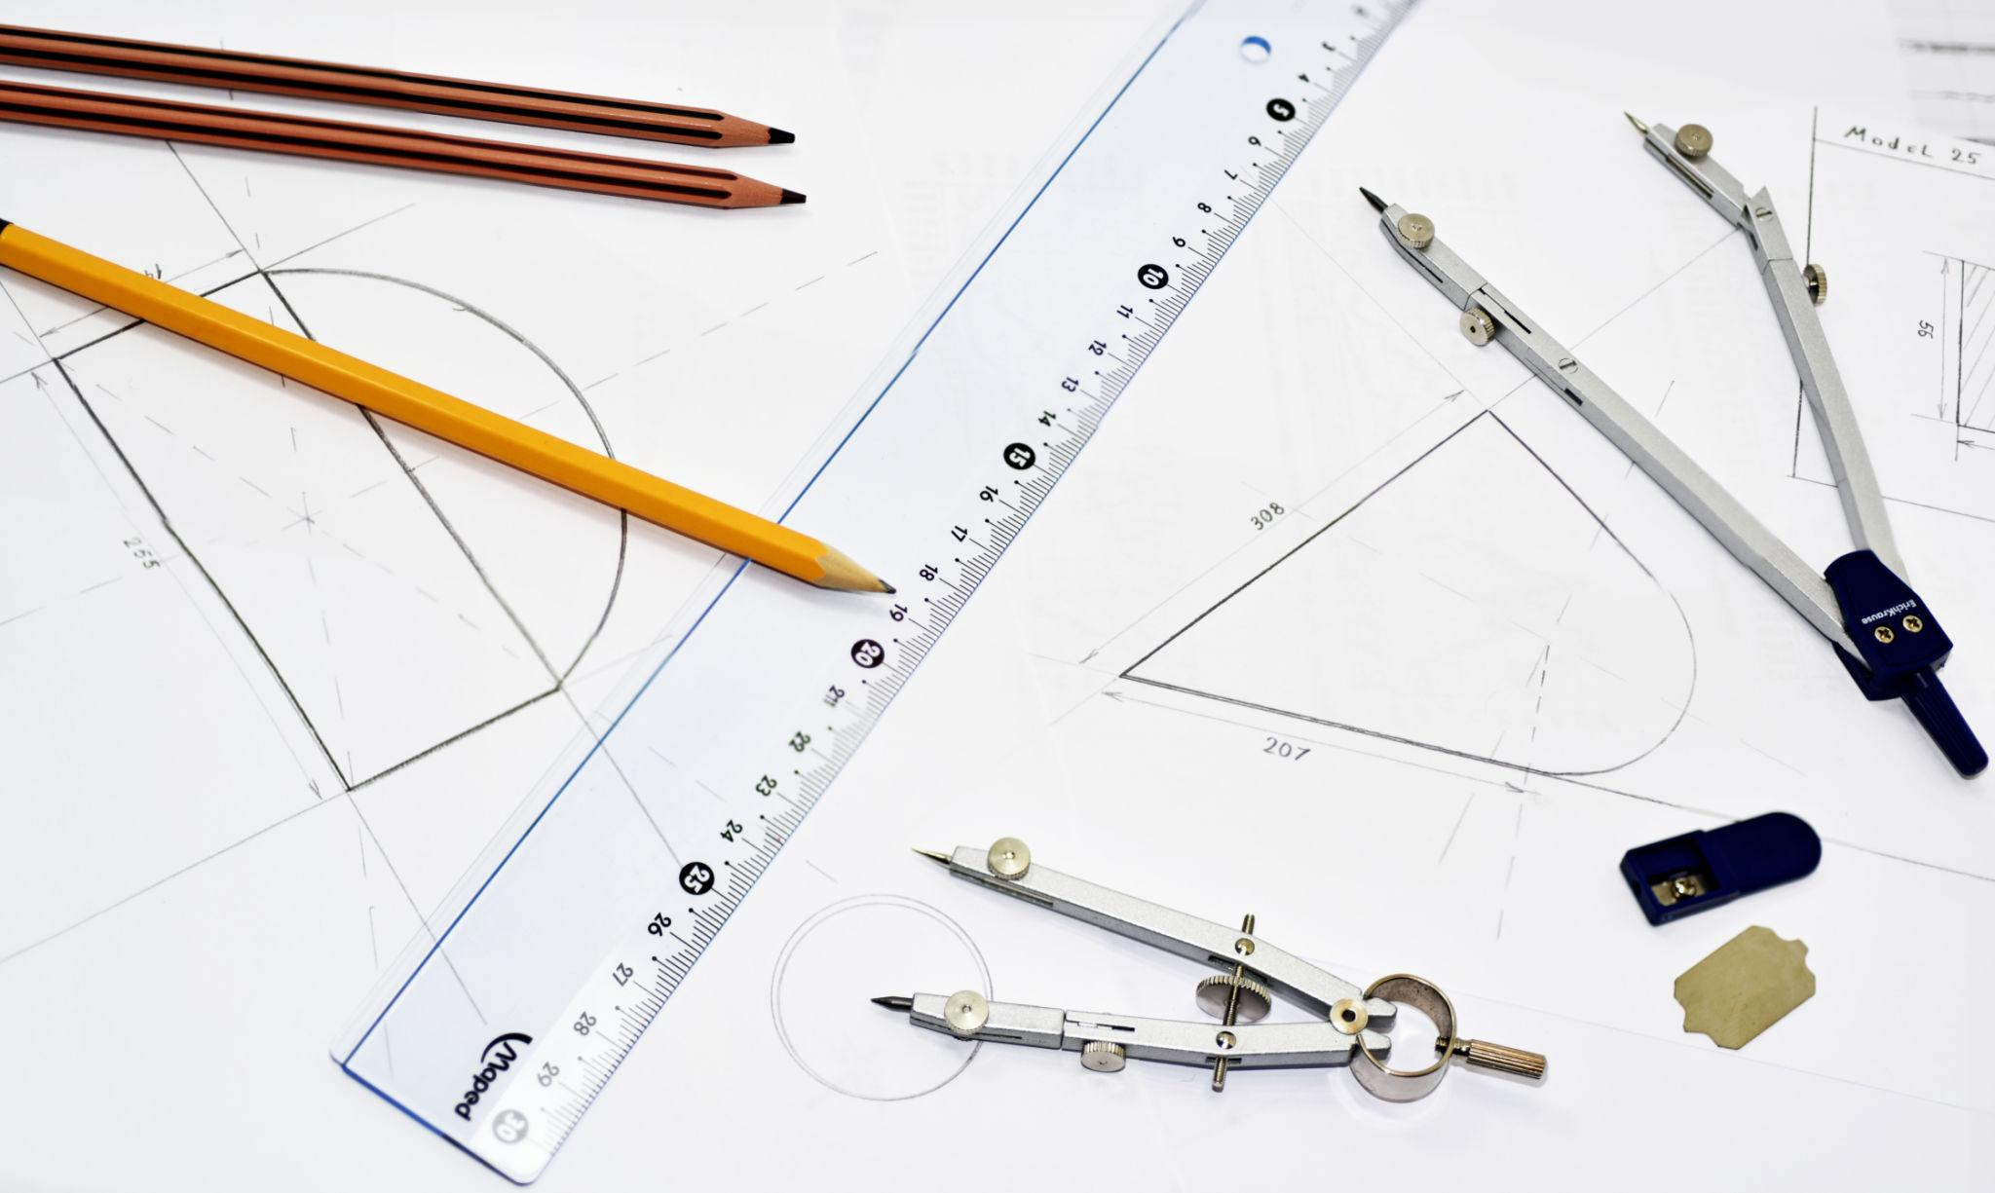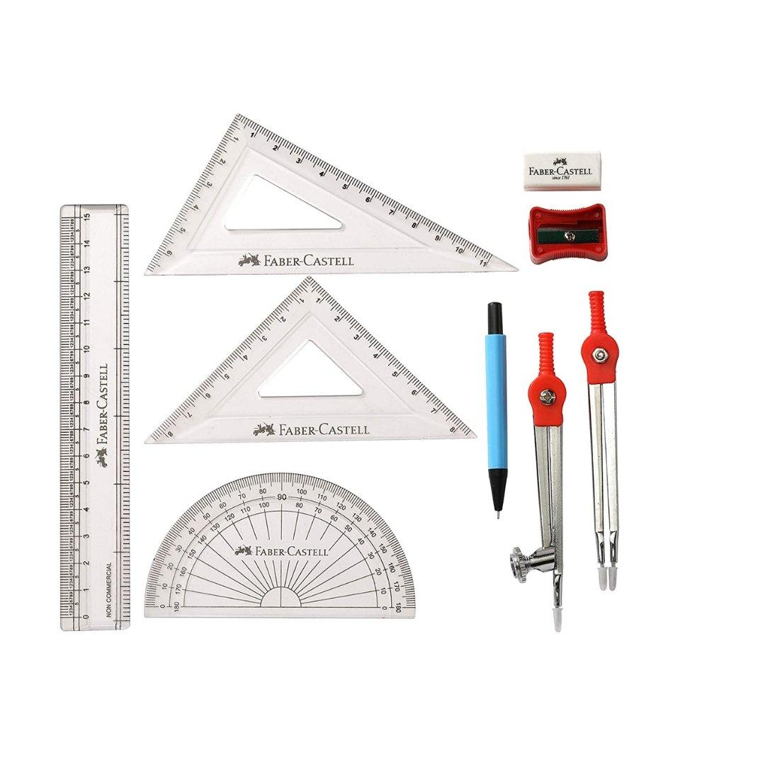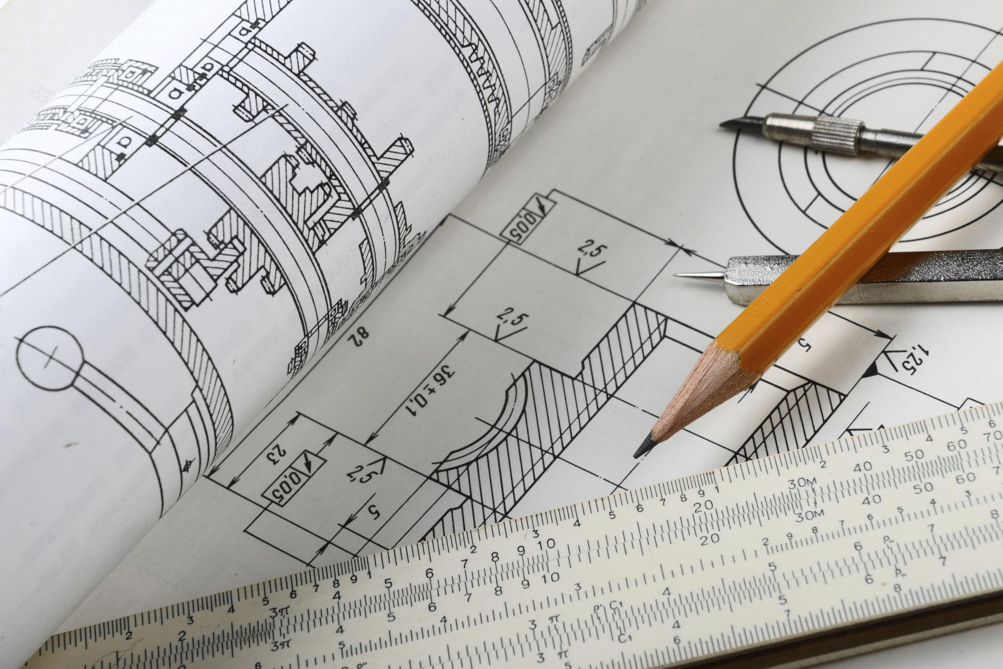
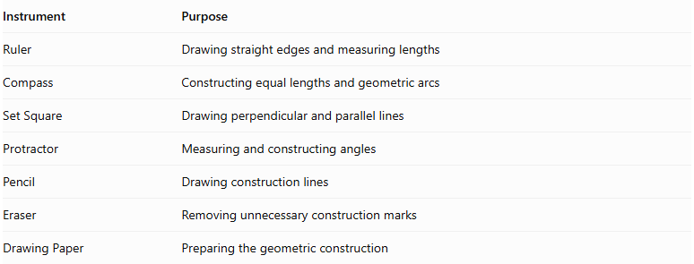
Instrument | Purpose
Ruler | Drawing straight edges and measuring lengths
Compass | Constructing equal lengths and geometric arcs
Set Square | Drawing perpendicular and parallel lines
Protractor | Measuring and constructing angles
Pencil | Drawing construction lines
Eraser | Removing unnecessary construction marks
Drawing Paper | Preparing the geometric construction
Construction Method: Instrument-Based

Construction Procedures

Constructing the Rectangular Base
# Source: AI Source: Provided by: [Data Path: Persons Table -> ID Column: 1, Name_En Column: Motasem Essam] -> From: [ChatGPT] on [7/25/2026]
- Draw a straight line representing the length of the rectangle.
- Construct perpendicular lines at its endpoints using a set square.
- Mark equal width measurements on the perpendicular lines.
- Connect the remaining endpoints to complete the rectangle.
- Label the four base vertices.

Constructing a Right Rectangular-Base Pyramid
# Source: AI Source: Provided by: [Data Path: Persons Table -> ID Column: 1, Name_En Column: Motasem Essam] -> From: [ChatGPT] on [7/25/2026]
- Construct the rectangular base.
- Draw the diagonals of the rectangle to locate its center.
- Draw a perpendicular line through the center of the base.
- Mark the desired perpendicular height on this line.
- Label the endpoint as the apex.
- Connect the apex to all four base vertices.
- Draw visible edges using solid lines.
- Draw hidden edges using dashed lines where appropriate.
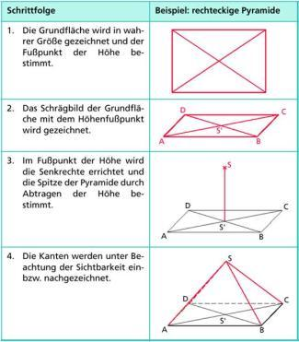

Constructing an Oblique Rectangular-Base Pyramid
# Source: AI Source: Provided by: [Data Path: Persons Table -> ID Column: 1, Name_En Column: Motasem Essam] -> From: [ChatGPT] on [7/25/2026]
- Construct the rectangular base.
- Select an apex position that is not directly above the center of the rectangle.
- Draw the apex above the base plane.
- Connect the apex to all four base vertices.
- Distinguish visible and hidden edges.
- Verify that the four lateral faces are triangular.
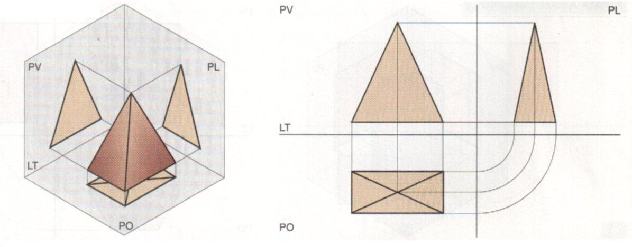

Constructing the Net of a Rectangular-Base Pyramid
# Source: AI Source: Provided by: [Data Path: Persons Table -> ID Column: 1, Name_En Column: Motasem Essam] -> From: [ChatGPT] on [7/25/2026]
- Draw a rectangle representing the base.
- Construct four triangular faces, one attached to each side of the rectangle.
- Determine the side lengths of each triangle from the corresponding lateral edges.
- Add joining flaps if the net is intended for physical assembly.
- Cut and fold the net to form the pyramid.
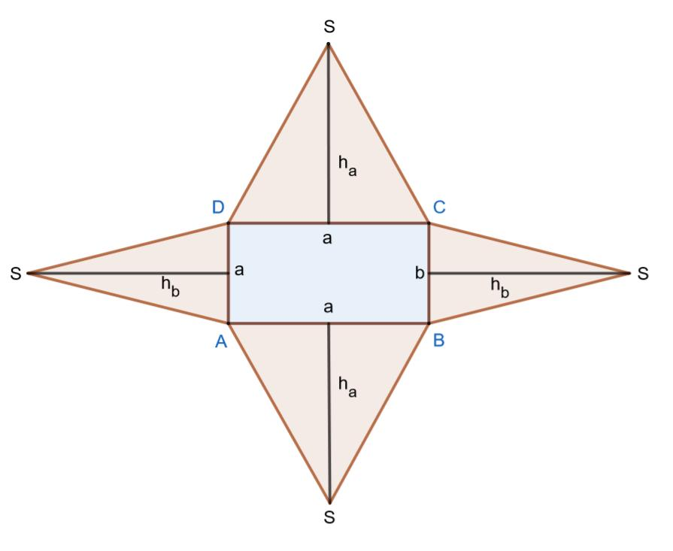

Applications
# Source: AI Source: Provided by: [Data Path: Persons Table -> ID Column: 1, Name_En Column: Motasem Essam] -> From: [ChatGPT] on [7/25/2026]
- Architecture: Modeling tapered roofs and structures with rectangular footprints.
- Engineering: Representing tapered components and solid parts with rectangular bases.
- Computer graphics: Building three-dimensional objects from triangular and rectangular polygons.
- Mathematics education: Exploring how base dimensions affect volume, slant heights, and surface area.
- Geometric modeling: Comparing right and oblique pyramids and understanding the effects of shifting the apex.

Key Points
# Source: AI Source: Provided by: [Data Path: Persons Table -> ID Column: 1, Name_En Column: Motasem Essam] -> From: [ChatGPT] on [7/25/2026]
- A rectangular-base pyramid has one rectangular base and four triangular lateral faces.
- It has 5 faces, 8 edges, and 5 vertices.
- The base area is $ab$, and the base perimeter is $2\left(a+b\right)$.
- Its volume is $\frac{1}{3}abh$.
- For a right rectangular-base pyramid, the lateral surface area is $al_{a}+bl_{b}$.
- A right rectangular-base pyramid generally has two different slant heights.
- Its perpendicular height is not the same as either slant height or a lateral edge.
- A square-base pyramid is a special case of a rectangular-base pyramid under the inclusive definition of a rectangle.

Conclusion
# Source: AI Source: Provided by: [Data Path: Persons Table -> ID Column: 1, Name_En Column: Motasem Essam] -> From: [ChatGPT] on [7/25/2026]
A rectangular-base pyramid is a polyhedron with a rectangular base and four triangular lateral faces that meet at one apex. It has five faces, eight edges, and five vertices. The rectangular base distinguishes it from other quadrilateral pyramids, while the position of the apex determines whether it is right or oblique.
Its volume is one-third of the rectangular base area multiplied by the perpendicular height. Its surface area is calculated by adding the areas of the base and all four lateral triangles. For a right rectangular-base pyramid, the two pairs of lateral faces generally have different slant heights, making its surface-area calculation different from that of a right square-base pyramid.

